# Name: Sushant Tulasi

# Class: D15B

# Roll: 60

# Experiment 02 : To design Flutter UI by including common widgets.

import 'package:flutter/material.dart';

void main() {

runApp(AccountApp());

}

class AccountApp extends StatelessWidget {

@override

Widget build(BuildContext context) {

return MaterialApp(

theme: ThemeData(

primaryColor: Color(0xFF6200EE),

colorScheme: ColorScheme.fromSeed(seedColor: Color(0xFF6200EE)),

useMaterial3: true,

),

home: Account(),

);

}

}

class Account extends StatelessWidget {

const Account({Key? key}) : super(key: key);

@override

Widget build(BuildContext context) {

return Scaffold(

backgroundColor: Theme.of(context).colorScheme.background,

appBar: AppBar(

centerTitle: true,

backgroundColor: Theme.of(context).colorScheme.primary,

leading: IconButton(

onPressed: () {

Navigator.pop(context);

},

icon: Icon(Icons.arrow_back, color: Colors.white),

),

title: Text(

"Settings",

style: TextStyle(color: Colors.white, fontWeight: FontWeight.bold),

),

),

body: SafeArea(

child: ListView(

padding: EdgeInsets.all(16),

children: [

_buildProfileCard(context),

SizedBox(height: 16),

_buildSectionCard(context, "Features", [

_buildListTile(context, "Memories", Icons.calendar_today, () {

print("You pressed Memories Button");

}),

_buildListTile(context, "Blocked Profile", Icons.block, () {

print("You pressed Blocked Profile Button");

}),

]),

SizedBox(height: 16),

_buildSectionCard(context, "Settings", [

_buildListTile(context, "Notifications", Icons.notifications, () {

print("You pressed Notifications Button");

}),

_buildListTile(context, "Time Zone", Icons.access_time, () {

print("You pressed Time Zone Button");

}),

_buildListTile(context, "Others", Icons.settings_suggest, () {

print("You pressed Others Button");

}),

]),

SizedBox(height: 16),

_buildSectionCard(context, "About", [

_buildListTile(context, "Share BeReal", Icons.share, () {

print("You pressed Share BeReal Button");

}),

_buildListTile(context, "Rate", Icons.star_outline, () {

print("You pressed Rate Button");

}),

_buildListTile(context, "Help", Icons.help_outline, () {

print("You pressed Help Button");

}),

_buildListTile(context, "About", Icons.info, () {

print("You pressed About Button");

}),

]),

],

),

),

);

}

Widget _buildProfileCard(BuildContext context) {

return Card(

elevation: 4,

shape: RoundedRectangleBorder(borderRadius: BorderRadius.circular(12)),

child: Padding(

padding: EdgeInsets.all(16),

child: Column(

children: [

CircleAvatar(

radius: 50,

backgroundColor: Theme.of(context).colorScheme.secondary,

child: Icon(Icons.person, size: 50, color: Colors.white),

),

SizedBox(height: 16),

Text(

"VESIT",

style: TextStyle(fontSize: 24, fontWeight: FontWeight.bold),

),

SizedBox(height: 8),

ElevatedButton(

onPressed: () {

print("You pressed Edit Profile Button");

},

child: Text("Edit Profile"),

style: ElevatedButton.styleFrom(

backgroundColor: Theme.of(context).colorScheme.primary,

foregroundColor: Colors.white,

),

),

],

),

),

);

}

Widget _buildSectionCard(BuildContext context, String title, List<Widget> children) {

return Card(

elevation: 2,

shape: RoundedRectangleBorder(borderRadius: BorderRadius.circular(12)),

child: Column(

crossAxisAlignment: CrossAxisAlignment.start,

children: [

Padding(

padding: EdgeInsets.all(16),

child: Text(

title,

style: TextStyle(fontSize: 20, fontWeight: FontWeight.bold),

),

),

Divider(height: 1),

...children,

],

),

);

}

Widget _buildListTile(BuildContext context, String title, IconData icon, VoidCallback onTap) {

return ListTile(

leading: Icon(icon, color: Theme.of(context).colorScheme.primary),

title: Text(title),

trailing: Icon(Icons.chevron_right),

onTap: onTap,

);

}

}

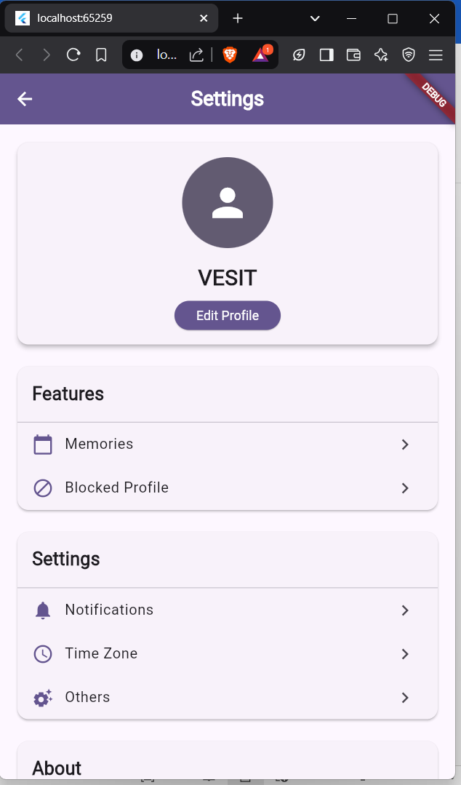

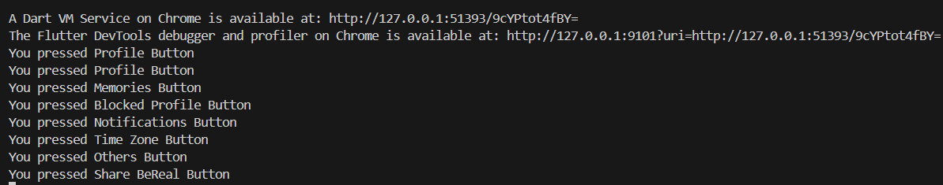

# Usage of Widgets:

* Widgets like Row, Column, SizedBox, ElevatedButton, and Align are used to structure the UI.
* The SafeArea widget ensures that content is displayed within the safe area of the screen.
* The SingleChildScrollView widget allows scrolling when the content overflows the screen

**List of Widgets** Flutter Scaffold Flutter Container Flutter Row & Column Flutter Text

Flutter TextField Flutter Buttons Flutter Stack Flutter Forms Flutter AlertDialog Flutter Icons Flutter Images Flutter Card Flutter Tabbar Flutter Drawer Flutter Lists Flutter GridView Flutter Toast Flutter Checkbox

Flutter Radio Button Flutter Progress Bar Flutter Snackbar Flutter Tooltip Flutter Slider

Flutter Switch Flutter Charts

Bottom Navigation Bar Flutter Themes

Flutter Table Flutter Calendar Flutter Animation